**Supplementary data**

Acoustic methodology

*Acoustic sampling*

Calibration of the two systems were done after Demer et al. (2015). For the EK80 system, a calibration was conducted at the field site at 40 m depth during the field campaign on the 27th July 2023 using a 38.1-mm tungsten calibration sphere hanging 8 meters below the transducer. The WBAT was calibrated on 11th May in Bergen, Norway, i.e. two months prior to the field campaign, at 10 m depth with a 38.1-mm tungsten calibration sphere hanging 7 meters below the transducer.

Transects covering distances from 0 to 600 m from the oil platform were sampled four times (19th and 27th July, Table S2) to investigate spatial patterns in fish distribution. The EK80 sampled acoustic data in the whole water column and the total acoustic backscatter (nautical area scattering coefficient (sA; m2 nmi-2) covering the whole water column, was used as a proxy for fish abundance. At around 30 m from the platform, reflections from the structure of the platform began to create noise, hiding backscatter from actual fish targets.

*Single target strength (TS) measurements*

In addition to spatial acoustic data collected along the entire transects, acoustic measurements were also made for ~4 min at the angling stations (10, 20, 40, 50, 100, 300 and 600 m from the platform). The shortest possible pulse duration of 128 µs was chosen to be able to capture acoustic targets as close to the sea floor as possible. With a sound speed of 1501 m s-1, a target had to be minimum 9.6 cm from the sea floor – and 9.6 cm from nearby targets - to be detected as a single target.

Due to reflections/echoes from the platform structure, TS measurements at 10 and 20 m from the platform could only be used down to ~14 m and ~20 m depth, respectively, and were not included in further data analyses.

*Temporal acoustic data*

The WBAT was deployed at the platform (0 m) and at 50 m and 300 m from the platform for a minimum of 24 hrs to investigate diel patterns in acoustic backscatter. Acoustic data was sampled using a ping rate interval of 0.4 s-1. A pulse duration of 128 µs was chosen to be comparable to the EK80. The WBAT were duty cycled and measured for 30 min followed by 30 min pause due to shortage of battery capacity.

The WBAT was placed in a metal rig for protection, and floats (outside the beam of the transducer) were attached to make the WBAT buoyant. Opposite the transducer, a rope connected the WBAT rig with an acoustic releaser (Sub Sea Sonic, AR60) which was weighted with 4x20 kg sandbags to keep the WBAT in place at the bottom until released by a deck unit from the boat 24 hours later.

Table 1. Settings applied for automatic single target detection using the acoustic analytical software LSSS (Ona 1999, Korneliussen et al. 2009).

|  |  |
| --- | --- |
| **Target detector settings** | **70 kHz (narrowband)** |
| Minimum TS (dB) | -80 |
| Pulse length determination level [dB] | 6 |
| Minimum echo length (relative to pulse length) | 0.8 |
| Maximum echo length (relative to pulse length) | 1.2 |

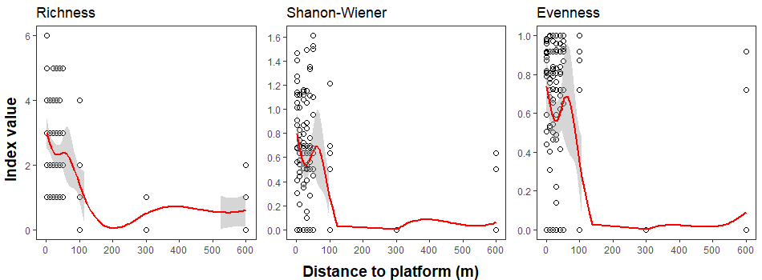

Figure 1. Non-linear trends of biodiversity indexes variation along the distance gradient.

Table 2. Summary of observed fish biodiversity (species richness, Shannon-Wiener biodiversity index, Pielou’s evenness index) and abundance (number of individuals) at each distance from the studied platform.

|  |  |  |  |  |  |  |  |  |  |  |
| --- | --- | --- | --- | --- | --- | --- | --- | --- | --- | --- |
| **Distance to platform** | **Mean abundance** | **SD abundance** | **Mean CPUE** | **SD CPUE** | **Mean species richness** | **SD species richness** | **Mean Shannon-Wiener** | **SD Shannon-Wiener** | **Mean Pielou's evenness** | **SD Pielou's evenness** |
| 1 | 13.67 | 7.05 | 43.73 | 23.39 | 3.11 | 1.37 | 0.84 | 0.41 | 0.76 | 0.25 |
| 10 | 16.19 | 7.95 | 54.33 | 34.48 | 2.38 | 0.96 | 0.55 | 0.35 | 0.58 | 0.35 |
| 20 | 10.50 | 3.49 | 33.58 | 17.10 | 2.50 | 1.20 | 0.58 | 0.41 | 0.57 | 0.35 |
| 30 | 12.88 | 12.20 | 38.15 | 36.53 | 2.50 | 1.03 | 0.60 | 0.42 | 0.61 | 0.36 |
| 40 | 8.11 | 4.90 | 24.05 | 14.75 | 2.22 | 1.17 | 0.53 | 0.44 | 0.57 | 0.39 |
| 50 | 6.06 | 3.34 | 17.99 | 9.89 | 2.44 | 1.41 | 0.68 | 0.54 | 0.67 | 0.41 |
| 100 | 2.19 | 2.04 | 6.58 | 6.27 | 1.38 | 0.96 | 0.28 | 0.40 | 0.34 | 0.46 |
| 300 | 0.75 | 1.06 | 2.20 | 3.08 | 0.50 | 0.52 | 0.00 | 0.00 | 0.00 | 0.00 |
| 600 | 1.33 | 1.61 | 3.97 | 4.79 | 0.61 | 0.70 | 0.06 | 0.19 | 0.09 | 0.27 |

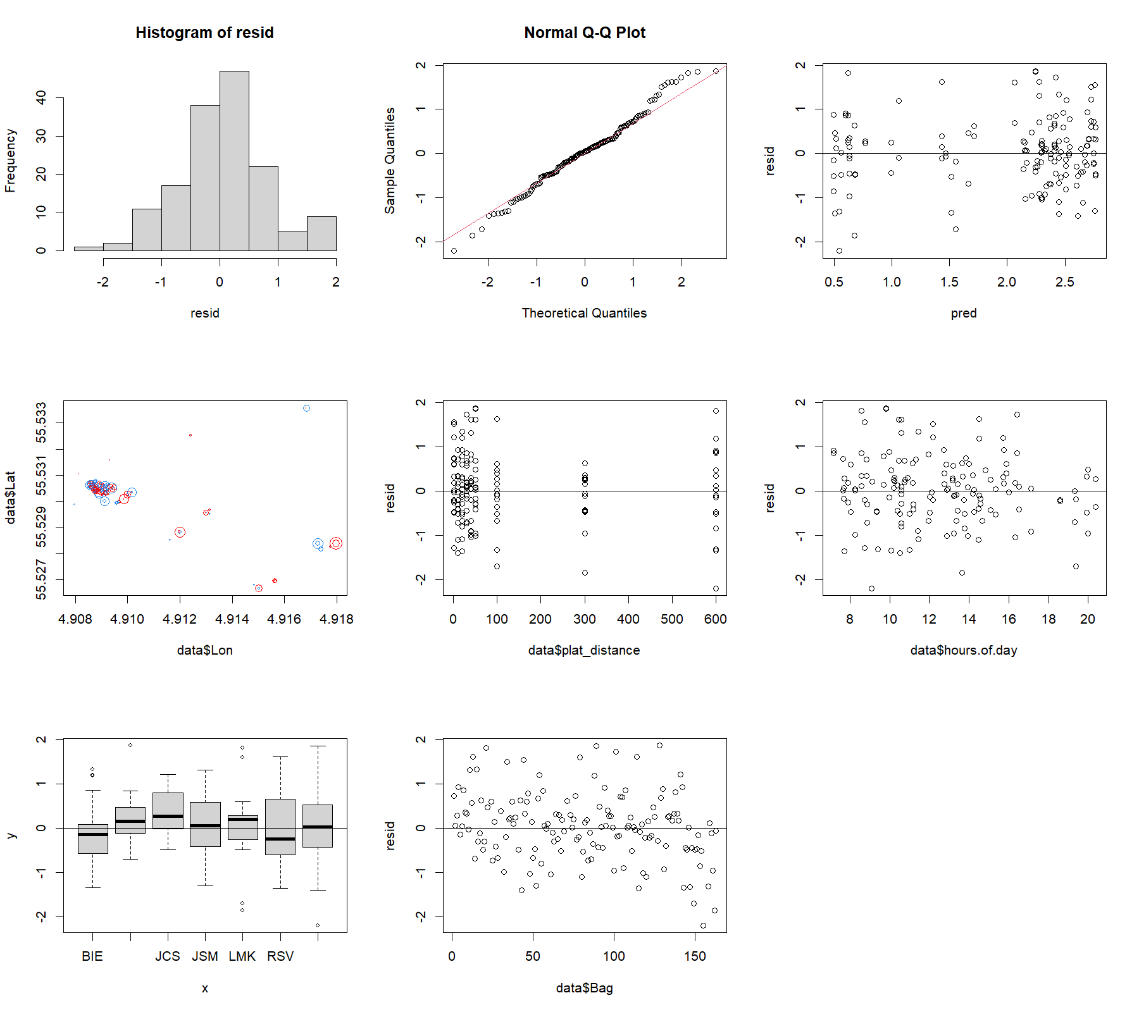

Figure 2. Fish biodiversity indexes model diagnostics for species richness.

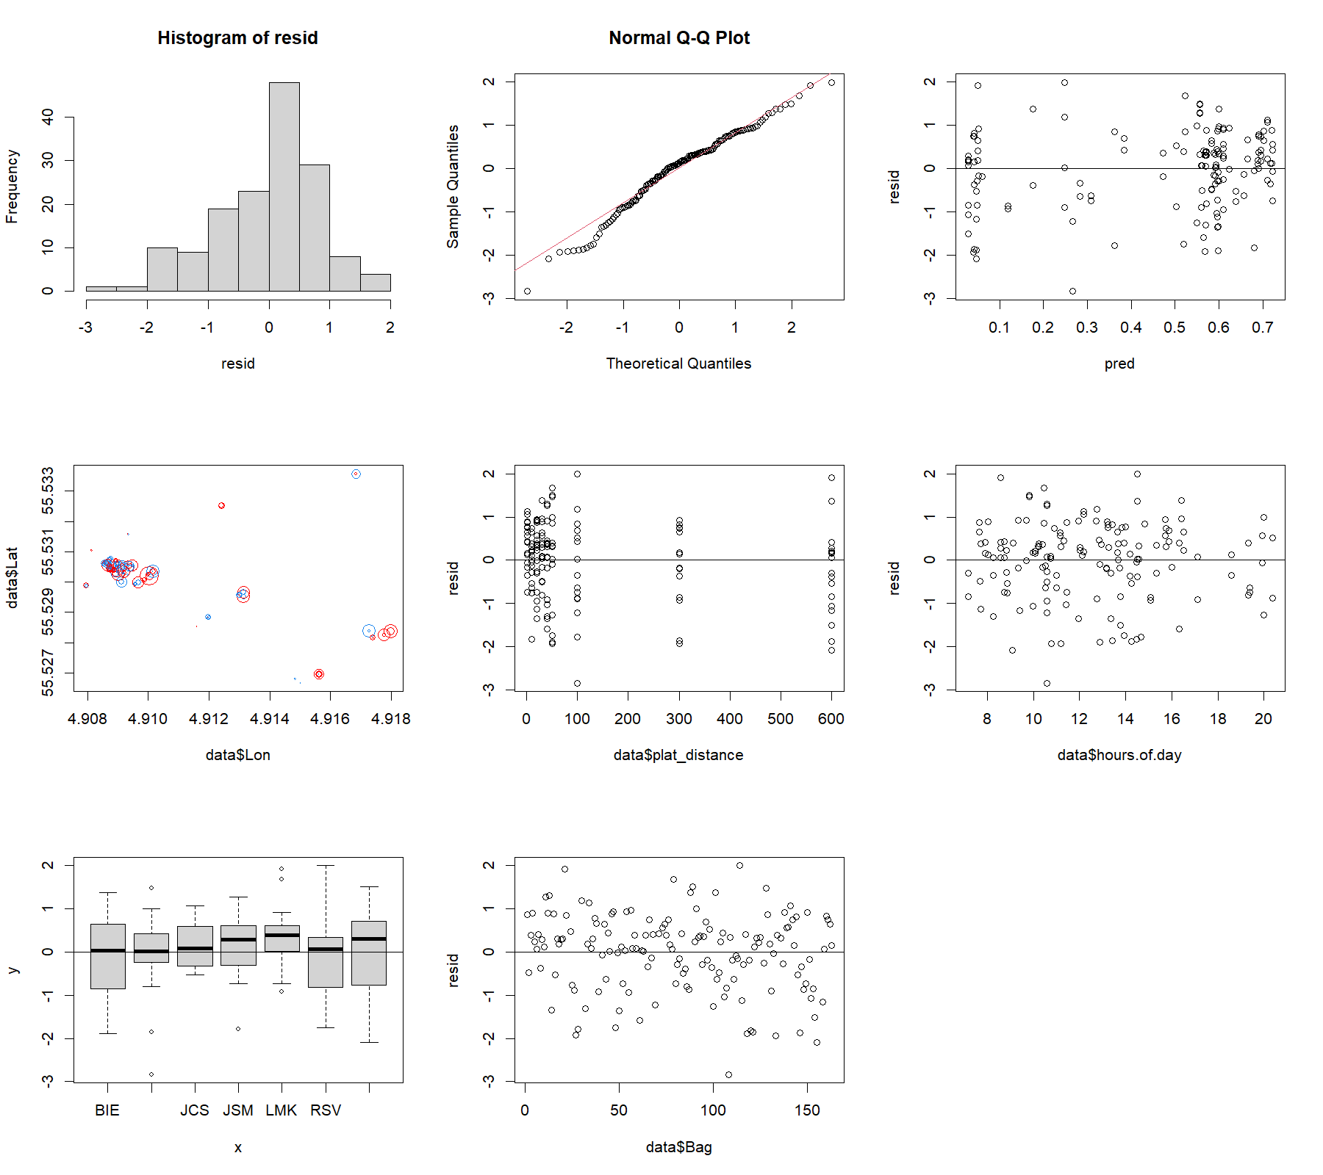

Figure 3. Fish biodiversity indexes model diagnostics for Shannon-Wiener biodiversity index.

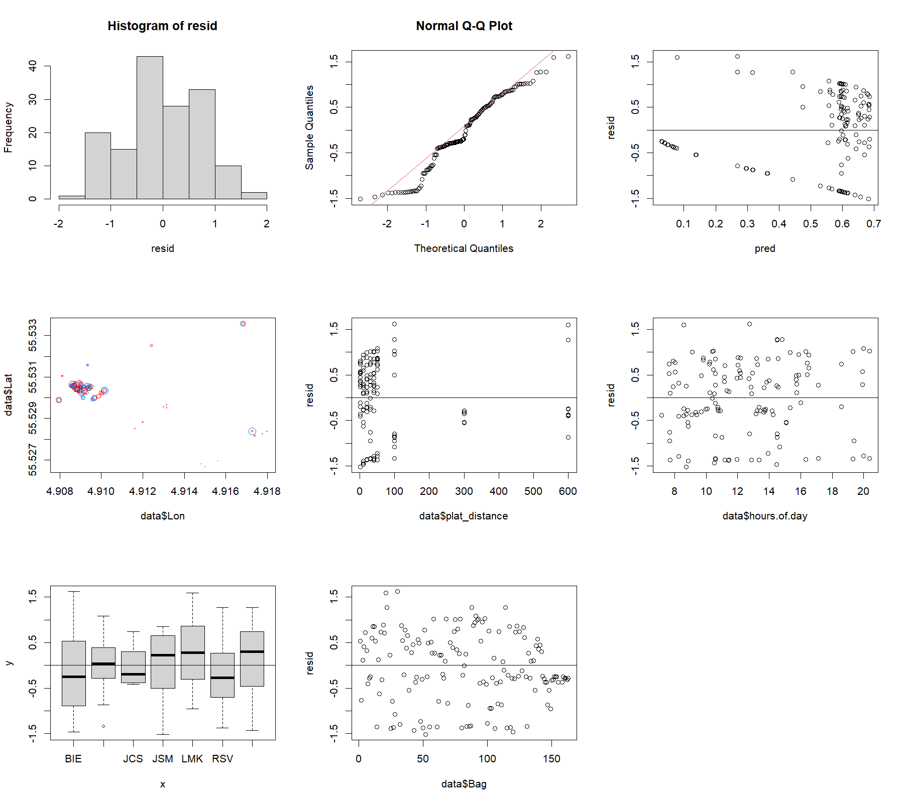

Figure 4. Fish biodiversity indexes model diagnostics for Pielou’s evenness index.

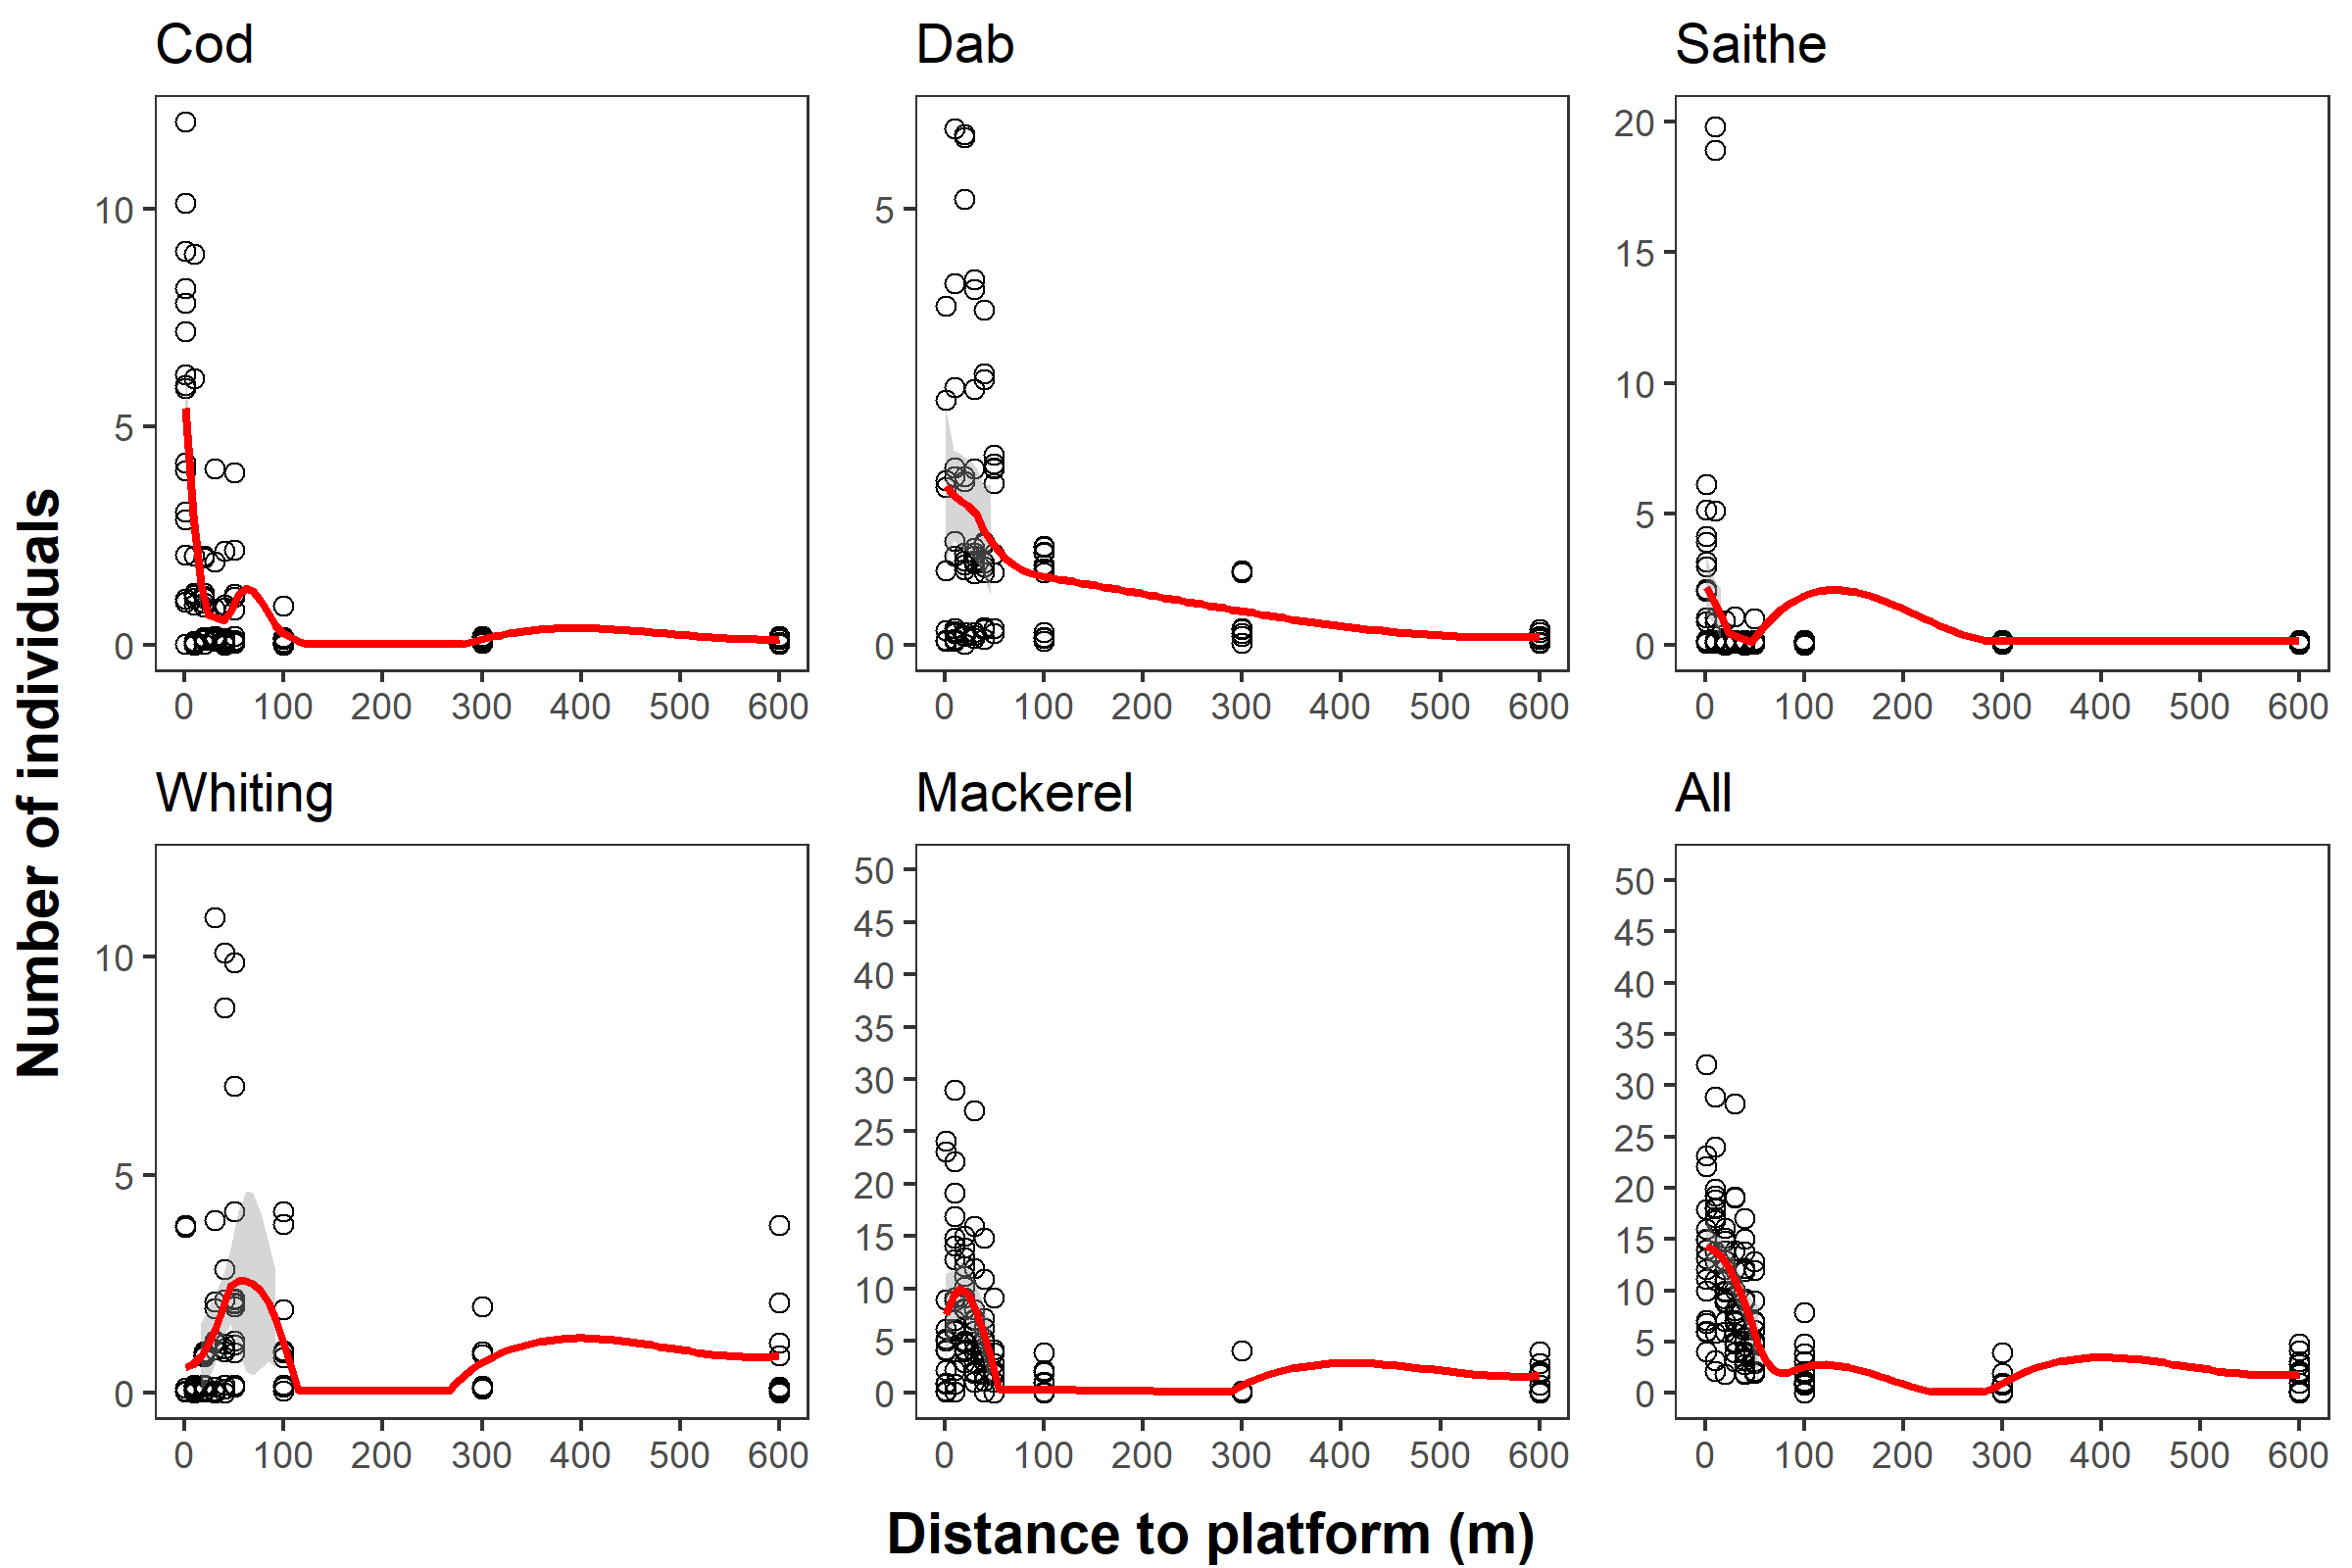

Figure 5. Non-linear trends of abundance variation along the distance gradient.

Table 3. Parameters and output of the generalized additive mixed models of the association of fish abundance (number of individuals) with the oil and gas (O&G) platform (spatial term coordinates ‘Lon, Lat’). An asterisk (*) represents statistical significance.

|  |  |  |  |  |  |  |  |
| --- | --- | --- | --- | --- | --- | --- | --- |
| **Species** | **Family** | **Goodness of fit, parametric coefficients** | **Smooth terms** | **Number of knots** | **Effective degrees of freedom** | **F-value / Chi-Square** | **p-value** |
| *Gadus morhua* | Gaussian | Adjusted R2 = 0.39; Deviance explained = 50.8%; REML = 51.54. Intercept: estimate = -2.19; standard error = 0.1; t-value = -21.95; p-value < 0.01. | s(Lon, Lat) | 6 | 4.2 | 7.4 | <0.01* |
| Binomial | Adjusted R2 = 0.26; Deviance explained = 26.7%; REML = 73.2. Intercept: estimate = -4.8; standard error = 0.6; z-value = -7.6; p-value < 0.01. | s(Lon, Lat) | 6 | 2.8 | 21 | <0.01* |
| s(time of the day) | 24 | 4.2 | 0 | 0.7 |
| *Limanda limanda* | Gaussian | Adjusted R2 = 0.43; Deviance explained = 51.6%; REML = 48.1. Intercept: estimate = -2.6; standard error = 0.15; t-value = -17.2; p-value < 0.01. | s(Lon, Lat) | 20 | 4 | 0.9 | <0.01* |
| Binomial | Adjusted R2 = 0.23; Deviance explained = 22.9%; REML = 88.4. Intercept: estimate = -3.8; standard error = 0.3; z-value = -11.4; p-value < 0.01. | s(Lon, Lat) | 20 | 5.3 | 16.1 | <0.01* |
|
| *Pollachius virens* | Gaussian | Adjusted R2 = 0.18; Deviance explained = 29.2%; REML = 24.7. Intercept: estimate = -2; standard error = 0.2; t-value = -9.5; p-value < 0.01. | s(distance to platform) | 5 | 1 | 2.5 | 0.14 |
| s(time of the day) | 24 | 1.2 | 0.2 | 0.3 |
| Binomial | Adjusted R2 = 0.31; Deviance explained = 36.1%; REML = 33.5. Intercept: estimate = -13.6; standard error = 11; z-value = -1.3; p-value = 0.2. | s(distance to platform) | 5 | 1.1 | 1.28 | 0.17 |
| s(time of the day) | 24 | 2.6 | 0 | 0.6 |
| *Merlangius merlangus* | Gaussian | Adjusted R2 = 0.55; Deviance explained = 70.1%; REML = 59.9. Intercept: estimate = -2.3; standard error = 0.13; t-value = -17.6; p-value < 0.01. | s(Lon, Lat) | 20 | 9.2 | 1.6 | <0.01* |
| s(time of the day) | 24 | 3.7 | 1.5 | <0.01* |
| Binomial | Adjusted R2 = 0.27; Deviance explained = 27.3%; REML = 60. Intercept: estimate = -3.9; standard error = 0.2; z-value = -19.1; p-value < 0.01. | s(Lon, Lat) | 20 | 8.9 | 22.8 | <0.01* |
| s(time of the day) | 24 | 3 | 10.7 | <0.01* |
| *Scomber scombrus* | Gaussian | Adjusted R2 = 0.27; Deviance explained = 37.8%; REML = 121.3. Intercept: estimate = -1.45; standard error = 0.08; t-value = -18.1; p-value < 0.01. | s(Lon, Lat) | 20 | 6 | 1.14 | <0.01* |
| s(time of the day) | 24 | 2.3 | 1.4 | <0.05* |
| Binomial | Adjusted R2 = 0.61; Deviance explained = 60.4%; REML = 69.3. Intercept: estimate = -2.1; standard error = 0.6; z-value = -3.5; p-value < 0.01. | s(Lon, Lat) | 20 | 13.2 | 98.7 | <0.01* |
| s(time of the day) | 24 | 1.7 | 7 | <0.01* |
| All species | Gaussian | Adjusted R2 = 0.63; Deviance explained = 69.6%; REML = 136. Intercept: estimate = -1.2; standard error = 0.1; t-value = -15.4; p-value < 0.01. | s(Lon, Lat) | 20 | 12.6 | 11.5 | <0.01* |
| s(time of the day) | 24 | 2.3 | 1.4 | <0.01* |
| Binomial | Adjusted R2 = 0.53; Deviance explained = 58.3%; REML = 36.3. Intercept: estimate = 0.6; standard error = 0.72; z-value = 0.84; p-value < 0.4. | s(Lon, Lat) | 20 | 7.5 | 30.1 | <0.01* |

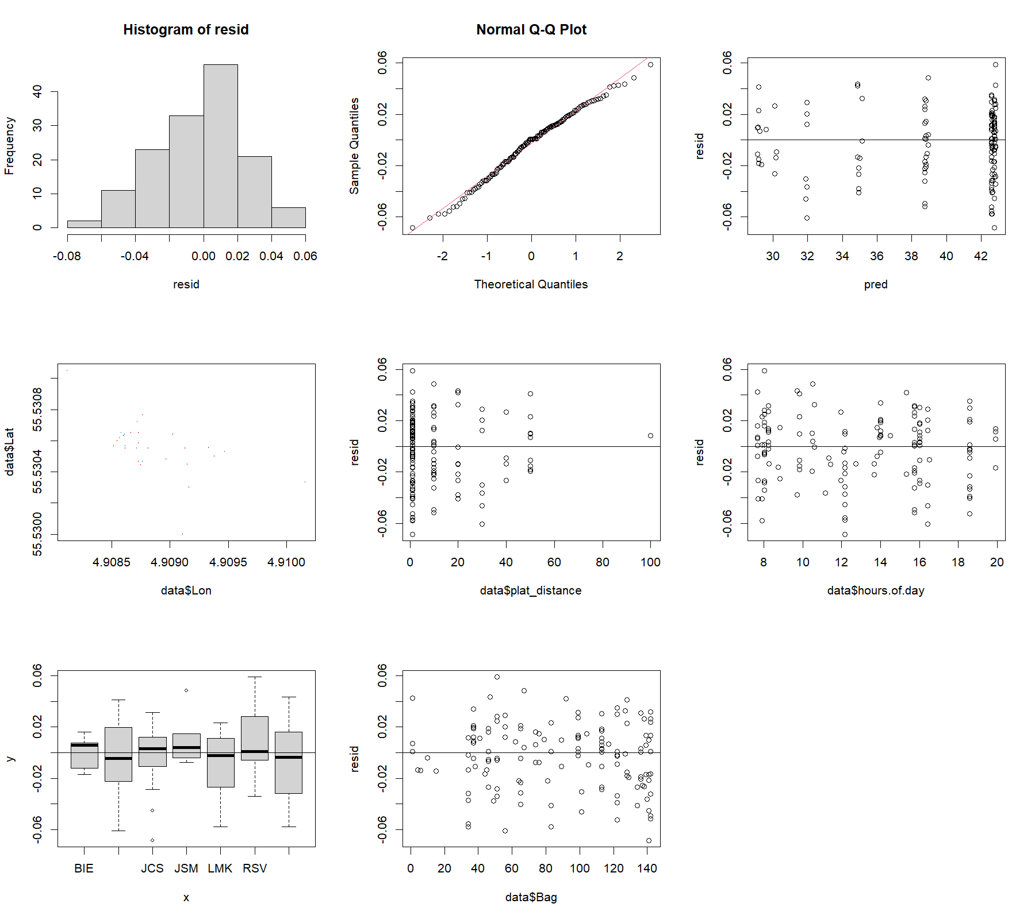

Figure 6. Fish abundance model diagnostics for Atlantic cod *Gadus morhua*.

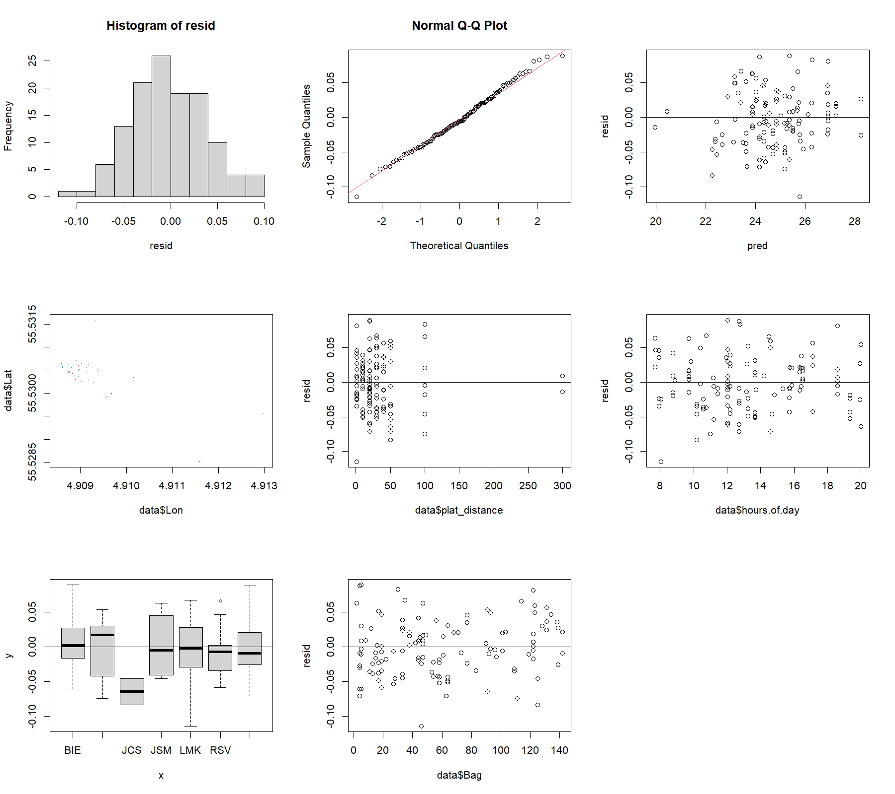

Figure 7. Fish abundance model diagnostics for dab *Limanda limanda*.

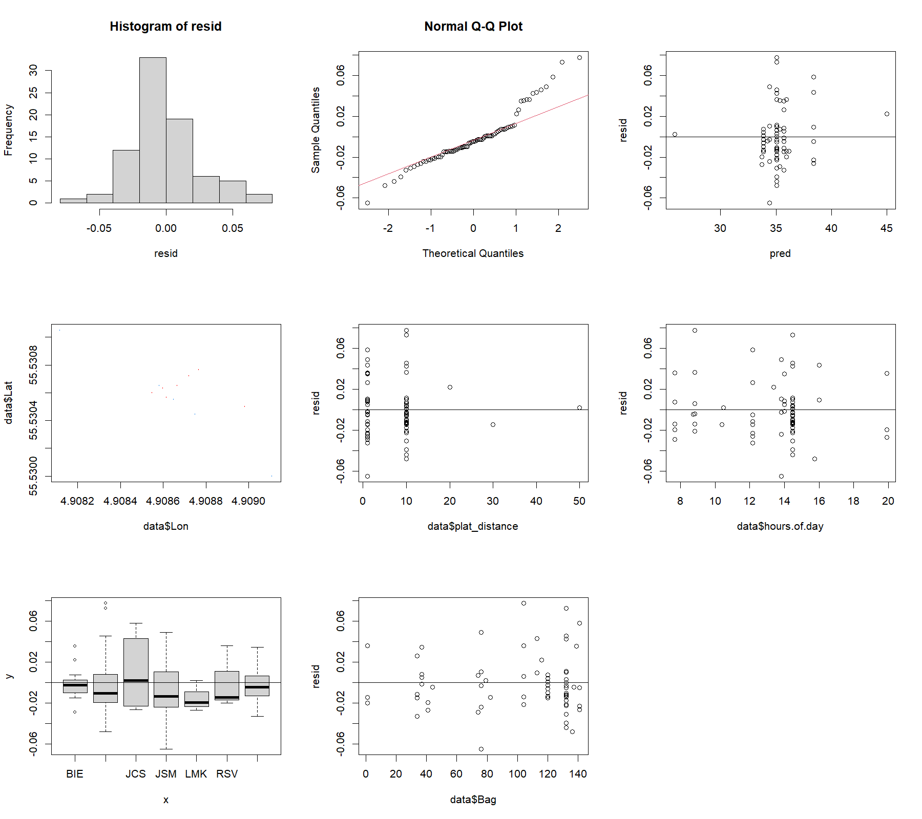

Figure 8. Fish abundance model diagnostics for saithe *Pollachius virens*.

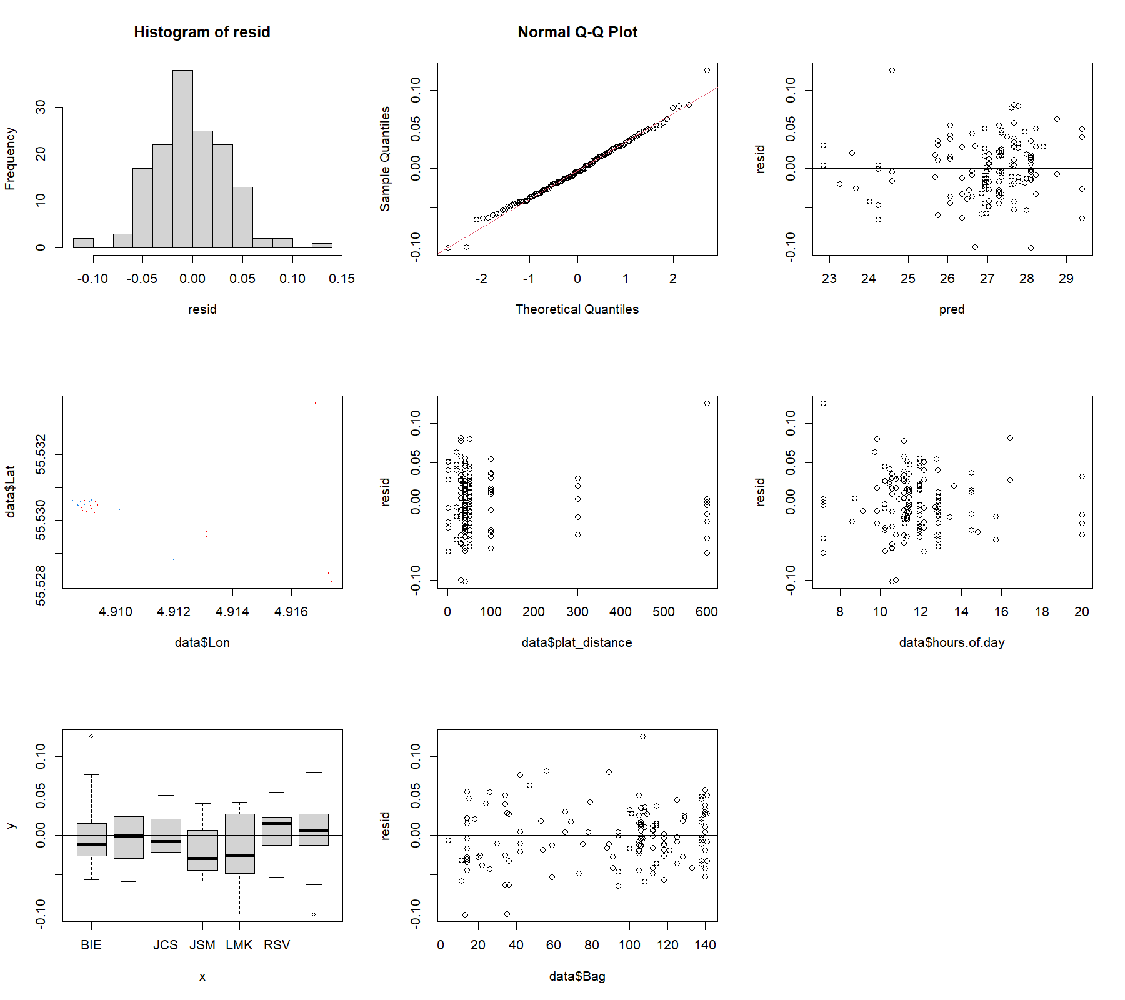

Figure 9. Fish abundance model diagnostics for whiting *Merlangius merlangus*.

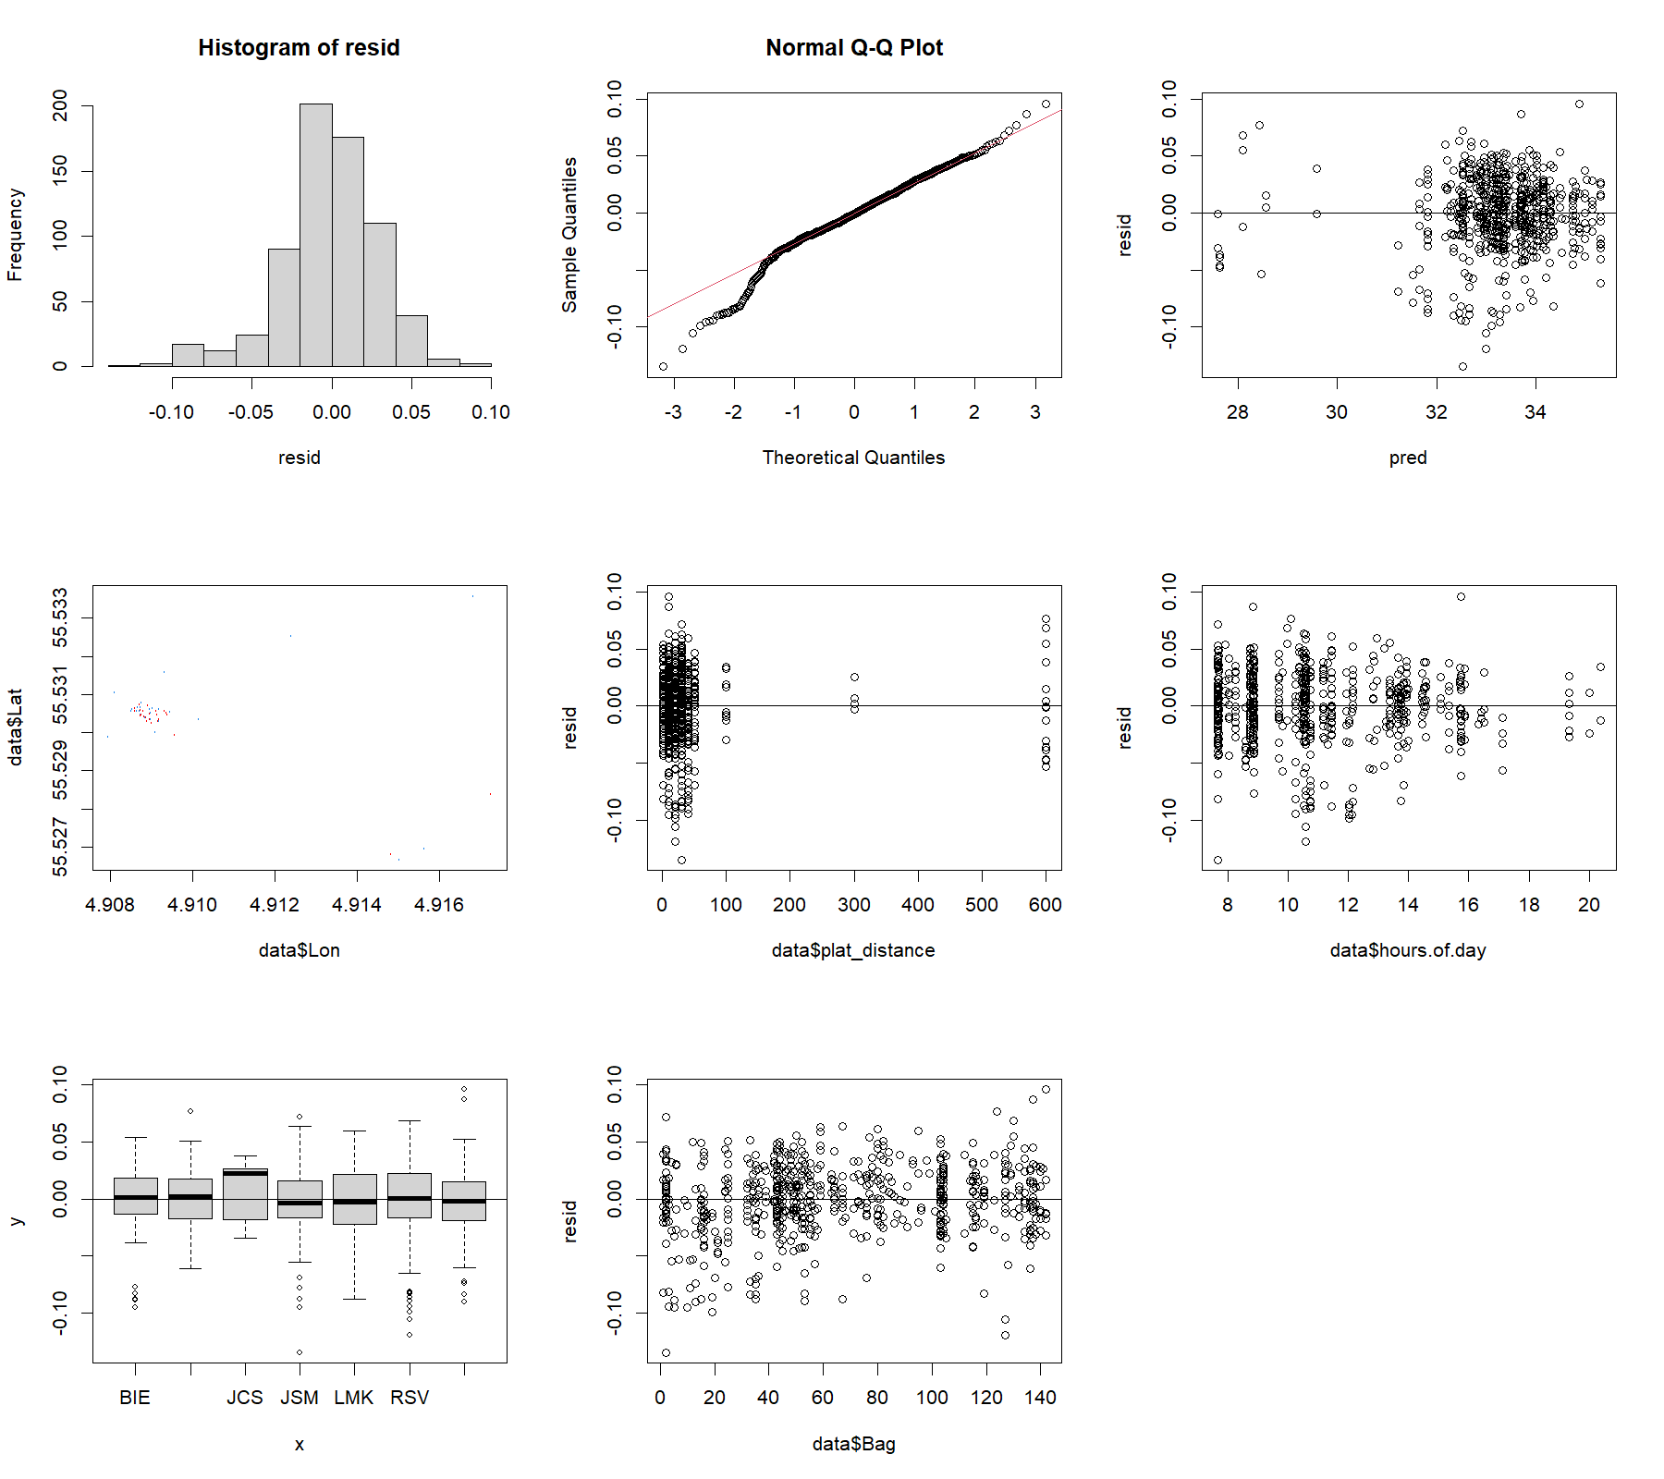

Figure 10. Fish abundance model diagnostics for mackerel *Scomber scombrus*.

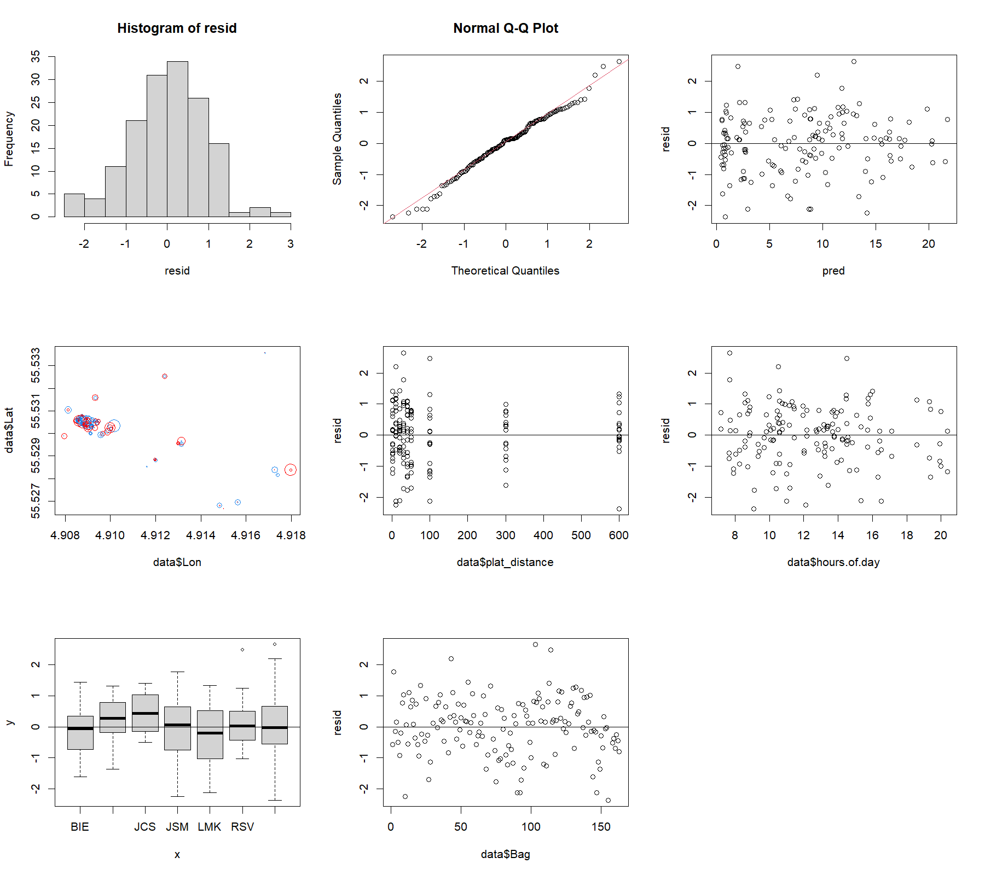

Figure 11. Fish abundance model diagnostics for total fish abundance (all species).

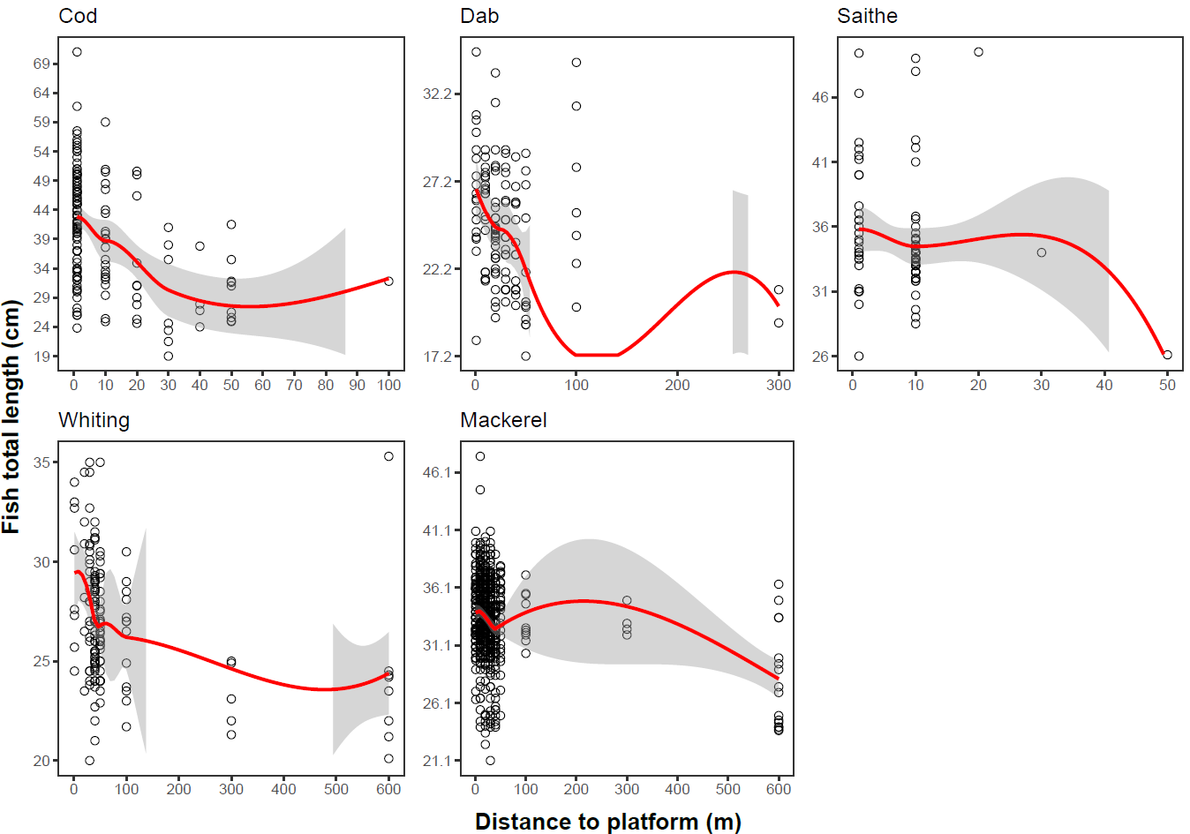

Figure 12. Non-linear trends of individual fish size variation along the distance gradient.

Table 4. Summary of observed and predicted individual fish sizes (total length in cm) per species at each distance from the studied platform.

|  |  |  |  |  |  |
| --- | --- | --- | --- | --- | --- |
| **Species** | **Distance to platform** | **Number of individuals** | **Mean total length (cm)** | **Standard deviation of total length (cm)** | **Predicted length** |
| *Gadus morhua* | 1 | 90 | 42.83 | 8.79 | 42.37 |
| *Gadus morhua* | 10 | 23 | 38.73 | 8.55 | 39.09 |
| *Gadus morhua* | 20 | 10 | 35.07 | 10.11 | 35.10 |
| *Gadus morhua* | 30 | 7 | 29.00 | 8.89 | 31.99 |
| *Gadus morhua* | 40 | 4 | 29.13 | 6.01 | 30.06 |
| *Gadus morhua* | 50 | 9 | 30.38 | 5.60 | 29.09 |
| *Gadus morhua* | 100 | 1 | 31.80 | NA | 29.43 |
| *Limanda limanda* | 1 | 18 | 26.73 | 3.67 | NA |
| *Limanda limanda* | 10 | 19 | 25.53 | 2.59 | NA |
| *Limanda limanda* | 20 | 31 | 24.58 | 3.14 | NA |
| *Limanda limanda* | 30 | 20 | 24.34 | 2.79 | NA |
| *Limanda limanda* | 40 | 15 | 23.56 | 2.68 | NA |
| *Limanda limanda* | 50 | 12 | 22.13 | 3.97 | NA |
| *Limanda limanda* | 100 | 7 | 26.50 | 4.98 | NA |
| *Limanda limanda* | 300 | 2 | 20.05 | 1.34 | NA |
| *Scomber scombrus* | 1 | 88 | 33.94 | 2.86 | 33.47 |
| *Scomber scombrus* | 10 | 171 | 34.04 | 3.22 | 33.29 |
| *Scomber scombrus* | 20 | 138 | 33.54 | 3.37 | 32.90 |
| *Scomber scombrus* | 30 | 153 | 32.97 | 3.40 | 32.53 |
| *Scomber scombrus* | 40 | 70 | 32.01 | 3.37 | 32.37 |
| *Scomber scombrus* | 50 | 31 | 33.73 | 3.29 | 32.08 |
| *Scomber scombrus* | 100 | 10 | 33.41 | 2.19 | 31.41 |
| *Scomber scombrus* | 300 | 4 | 33.13 | 1.31 | 31.47 |
| *Scomber scombrus* | 600 | 16 | 28.18 | 4.39 | 27.94 |
| *Pollachius virens* | 1 | 31 | 35.81 | 5.10 | NA |
| *Pollachius virens* | 10 | 46 | 34.47 | 4.08 | NA |
| *Pollachius virens* | 20 | 1 | 49.50 | NA | NA |
| *Pollachius virens* | 30 | 1 | 34.00 | NA | NA |
| *Pollachius virens* | 50 | 1 | 26.10 | NA | NA |
| *Merlangius merlangus* | 1 | 8 | 29.43 | 3.62 | 28.56 |
| *Merlangius merlangus* | 20 | 6 | 29.27 | 3.99 | 27.97 |
| *Merlangius merlangus* | 30 | 22 | 28.20 | 3.64 | 27.56 |
| *Merlangius merlangus* | 40 | 51 | 26.98 | 2.50 | 27.36 |
| *Merlangius merlangus* | 50 | 34 | 26.77 | 2.50 | 26.99 |
| *Merlangius merlangus* | 100 | 13 | 26.20 | 2.64 | 25.73 |
| *Merlangius merlangus* | 300 | 5 | 23.26 | 1.67 | 23.26 |
| *Merlangius merlangus* | 600 | 8 | 24.39 | 4.69 | 24.63 |



Figure 13. Individual fish size model diagnostics for Atlantic cod *Gadus morhua*.



Figure 14. Individual fish size model diagnostics for whiting *Merlangius merlangus*.



Figure 15. Individual fish size model diagnostics for mackerel *Scomber scombrus*.



Figure 16. Individual fish size model diagnostics for dab *Limanda limanda*.



Figure 17. Individual fish size model diagnostics for saithe *Pollachius virens*.

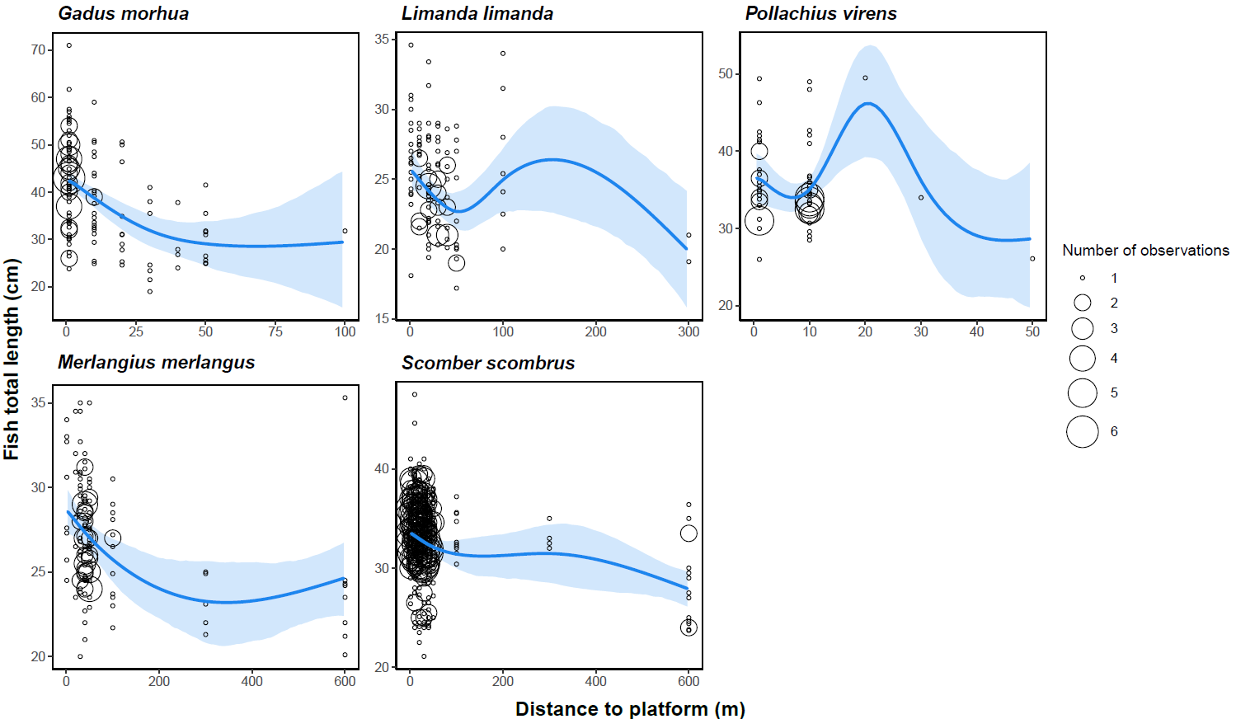

Figure 18. Predicted individual fish size (total length in cm) from the fitted generalized additive models (distance GAM) along the distance gradient from the studied platform for cod *Gadus morhua*, dab *Limanda limanda*, saithe *Pollachius virens*, whiting *Merlangius merlangus*, and mackerel *Scomber scombrus*. Blue curve = predicted individual fish size, light blue shaded area = 95% confidence intervals, circles = observed individual fish sizes, circle size = number of observations (i.e., occurrence) of a y-axis value. Included are the outlier point for cod at 100 m, and predicted values for non-validated models (dab and saithe).

Figure 19. Temperature and salinity profiles of the water column measured within 500 m from the oil platform Skjold using a CTD (CastAway) on 27 July 2023.

Figure 20. The echogram displays the backscattering strength (S-v; dB re 1 m−1) from surface to bottom (40 m depth) along four transects (See the other transect below and in the main paper), in a straight line from ~600 m distance to the main part of the platform (A). ‘B’ marks a single platform leg. The higher the backscatter (i.e. stronger targets) the redder the color. White means no backscatter. The bottom gives a lot of backscatter indicated by red. Single fish targets are green and some are pointed out by arrows. Purple single targets are weaker targets, such as fish with no swimbladder, jellyfish or large crustaceans. It is evident that there are single targets within the pycnocline, including some larger fish. There is a lot of reflection/noise from the oil platform, from around 30 m distance and closer to the platform. Note that due to waves moving the RIB boat up and down, the acoustic backscatter in the echograms appear wave-shaped.

Figure 21. Single target counts during 4 minutes stationary acoustic measurements at 40, 50, 100, 300 and 600 m distance to the oil platform. Roughly, two distinct size classes are evident based on the target strength (TS, dB): one group with a TS > -40 dB and another < -40 dB. Note that due to the EK80 echosounder being stationary, the same target may have been measured several times. Thus, the number of targets detected is only a relative measure of the actual number of targets present at each station, but stations are directly comparable across distances.

Table 5. Number of single targets with target strength (TS; dB) below and above -40 dB measured during 4 minutes at different distances (40, 50, 100, 300 and 600 m to the oil platform). Larger targets are defined by TS >= -40 dB, whereas smaller targets are defined by TS < -40 dB.

|  |  |  |  |
| --- | --- | --- | --- |
| Depth interval (m) | Distance to oil platform | Targets >= -40 dB | Targets < 40 dB |
| 5-10 m | 40 | 0 | 13 |
| 10-15 m | 40 | 1 | 46 |
| 15-20 m | 40 | 1 | 125 |
| 20-25 m | 40 | 0 | 279 |
| 25-30 m | 40 | 0 | 170 |
| 30-35 m | 40 | 53 | 211 |
| 35-40 m | 40 | 33 | 139 |
| 5-10 m | 50 | 0 | 5 |
| 10-15 m | 50 | 0 | 101 |
| 15-20 m | 50 | 0 | 76 |
| 20-25 m | 50 | 0 | 240 |
| 25-30 m | 50 | 0 | 129 |
| 30-35 m | 50 | 1 | 503 |
| 35-40 m | 50 | 35 | 281 |
| 5-10 m | 100 | 0 | 17 |
| 10-15 m | 100 | 0 | 51 |
| 15-20 m | 100 | 0 | 76 |
| 20-25 m | 100 | 0 | 140 |
| 25-30 m | 100 | 0 | 100 |
| 30-35 m | 100 | 0 | 48 |
| 35-40 m | 100 | 0 | 30 |
| 5-10 m | 300 | 0 | 40 |
| 10-15 m | 300 | 0 | 41 |
| 15-20 m | 300 | 0 | 95 |
| 20-25 m | 300 | 0 | 148 |
| 25-30 m | 300 | 3 | 102 |
| 30-35 m | 300 | 1 | 105 |
| 35-40 m | 300 | 0 | 61 |
| 5-10 m | 600 | 0 | 132 |
| 10-15 m | 600 | 0 | 40 |
| 15-20 m | 600 | 0 | 56 |
| 20-25 m | 600 | 0 | 125 |
| 25-30 m | 600 | 0 | 180 |
| 30-35 m | 600 | 0 | 167 |
| 35-40 m | 600 | 0 | 76 |

Table 6. The total number of targets detected in the water column from 5-40 m depth, during 4 minutes acoustic measurements at different distances to the oil platform. Targets with a TS from -20 to -40 dB are considered one size group (larger/stronger targets) and targets with TS from -40 to -80 dB are considered another size group (smaller/weaker targets).

|  |  |  |  |
| --- | --- | --- | --- |
| Distance to platform (m) | Total number of targets  TS >= -40 dB | Total number of targets  TS < 40 dB | Total number of targets |
| 40 | 88 | 983 | 1071 |
| 50 | 36 | 1335 | 1371 |
| 100 | 0 | 462 | 462 |
| 300 | 4 | 592 | 596 |
| 600 | 0 | 776 | 776 |

Figure 22. Acoustic echogram collected for 24 hrs (data collected in 30 min intervals followed by a 30 min break) by the WBAT during 21-22 July 2023, 50 m distance from the platform. Data collected from 14:00 on the 21st of July until 13:30 on the 22nd of July 2023. Every thick black line marks 2 hrs time intervals. Some vertical spike noise is also evident on the echogram, which could be from echosounders on service ships that were moving between O&G platforms in the area, and/or from fishing boats which were also present in the area.

Figure 23. Acoustic echogram collected for ~42 hrs (data collected in 30 min intervals followed by a 30 min break) by the WBAT during 27-29 July 2023, 300 m from the platform. Data collected from 13:00 on the 27th of July until 06:30 on the 29th of July 2023. Note that there is less surface noise at 300 m, compared to what was observed in the echograms at 0 and 50 m from the platform.